## Measurement Tools

The measurement tools will enable you to quickly measure distances, angles and areas on your plan. Measurements are precise, zoom-independent and can be saved as marker objects.

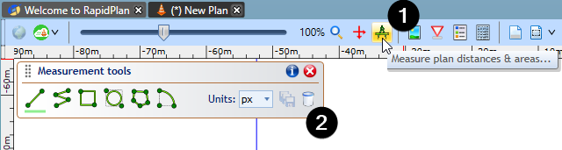

Click on to the measurement tools button to bring up the toolbar - there are 6 different measurement tools to work with as well as appropriate measurement units to apply.

Each measurement tool just requires a click and then another click at desired point/s to find the measurement between different points.

| Measurement Tools |  |
| --- | --- |
| Two_Points | Measure distance between 2 points |
| Along_Path | Measure distance along a path |
| Rectangular_Area | Measure a rectangular area |
| Elliptical_Area | Measure circular/elliptical area |
| Any_Area | Measure any area |
| Angle_Between_Two_Lines | Measure angle between two lines |

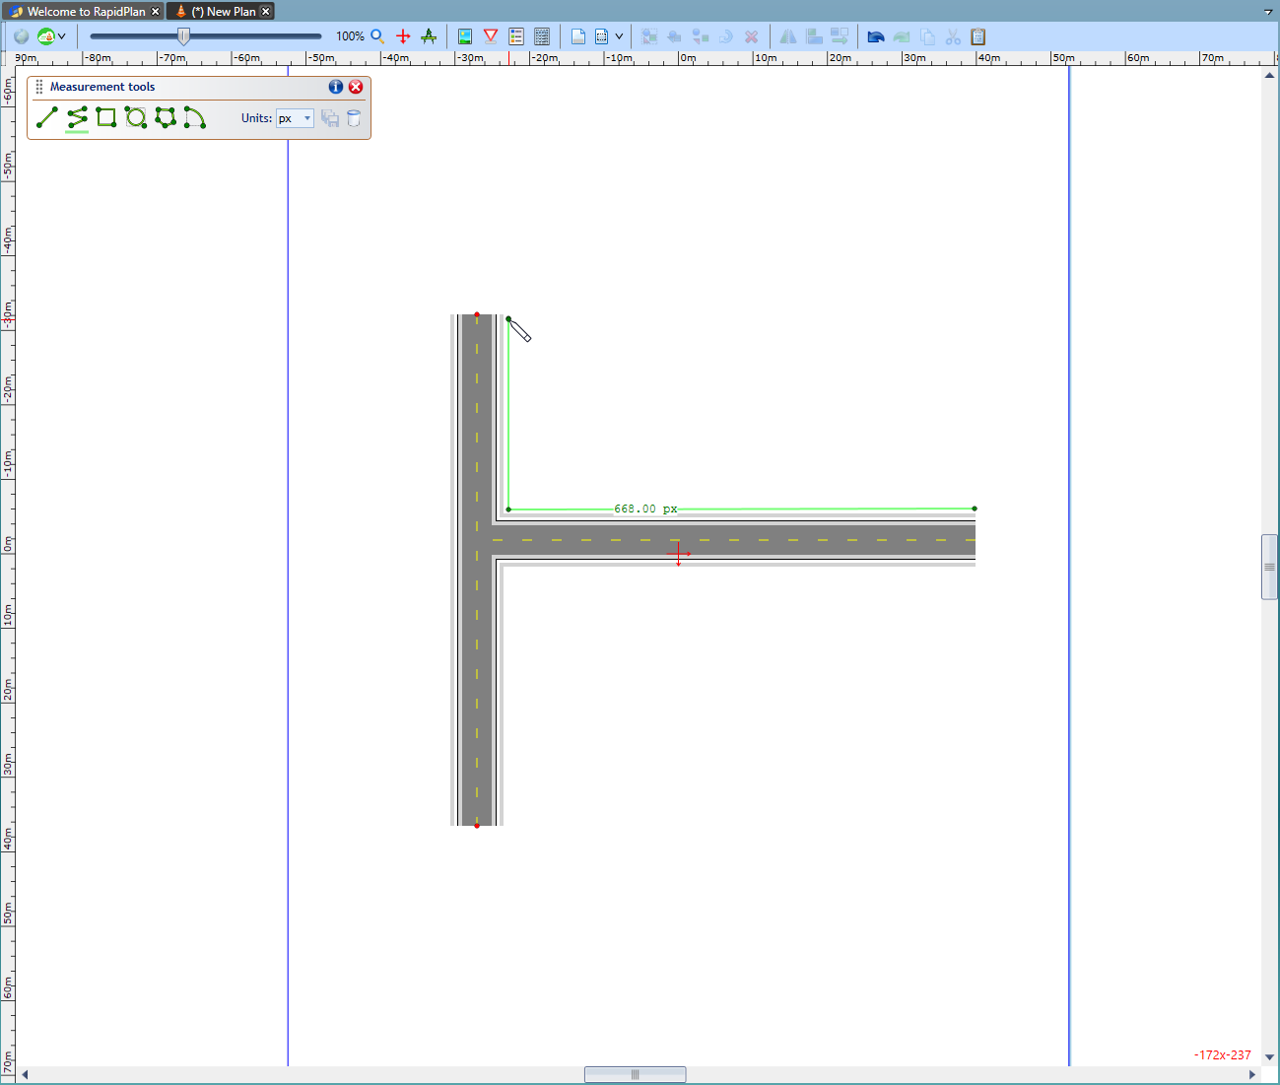

Distance\_along\_a\_path\_measurement